**KWAME NKRUMAH UNIVERSITY OF SCIENCE AND TECHNOLOGY**

**COLLEGE OF SCIENCE**

**DEPARTMENT OF COMPUTER SCIENCE**



**MINI - PROJECT DOCUMENTATION**

**PROJECT TOPIC**

**WASTE AND RECYCLING SYSTEM**

**PRESENTED BY:**

**NAME CONTACT INDEX NUMBER**

**ADU VINCENT KARIKARI 0543389712 4602318**

**TABLE OF CONTENT**

DECLARATION 2

APPROVAL 2

ABSTRACT 5

CHAPTER 1 – INTRODUCTION 7

1.0 - Background 7

1.1 - Problem Statement 9

1.2 - Aim Of The Project 9

1.3 - Specific Objectives 9

1.4 - Project Scope 9

1.5 - Project Justification 10

1.6 - Project Beneficiaries 10

CHAPTER 2 - REVIEW OF RELATED WORKS 11

2.0 - Review Of Related Systems 11

2.1 - Overview Of System 1: Incineration 11

2.1.1 - Good Features 11

2.1.2 - Bad Features 12

2.2 - Overview Of System 2: Landfills 13

2.2.1 - Good Features 13

2.2.2 - Bad Features 14

2.3 - Overview Of System 3: Dumpsites 14

2.3.1 - Good Features 14

2.3.2 - Bad Features 14

CHAPTER 3 – REQUIREMENT SPECIFICATION 15

3.1 – Overview 15

3.2 –Functional and Non-Functional Requirements 15

3.2.1 – Non – Functional Requirement. 15

3.2.1 – Functional Requirement. 15

3.3 – User and System Requirements 16

3.3.1 – User Requirement. 16

3.3.2 – System Requirement. 16

CHAPTER 4 - METHODOLOGY 17

4.0 - Overview 17

4.1 - Project Method Adopted And Justification 17

4.1.1 – Incremental model 17

4.2 – Project Design 18

4.2.1 – Customer Interface Application. 18

4.3.1 – Driver Interface Application. 25

4.4.1 –Administrator Interface Application. 29

CHAPTER 5 - IMPLEMENTATION AND TESTING 34

5.0 - Development Tools And Platforms Consideration 34

5.1 Mapping Logical Design Onto Physical Platforms 34

5.2 - Testing 34

6.0 - Discussions 35

6.1 - Achievements 35

6.2 - Conclusions 35

6.4 - Recommendations 35

6.5 - References 36

# **DECLARATION**

This project work entitled “Waste and Recycling System” is submitted to the College of Science in partial fulfillment of the requirements for the award of the Degree of Bachelor of Science in Computer Science of Kwame Nkrumah University of Science and Technology.

# **APPROVAL**

This project proposal has been presented for examination with my approval as the supervisor.

Dr. Gaddafi Abdul-Salaam (Ph. D.)

SIGNATURE………………………………DATE………………………………

# ABSTRACT

The purpose of this research is implemented based on web app which optimize waste collecting schedules by providing route optimization and operational analysis and allowing individuals, institutions and companies to sign up to the services the system provides. The software model used in used in developing this system is incremental model of System Development Life Cycle (SDLC). It has the following phases: analysis design, implementation, testing, maintenance in which each iteration passes through the requirements, design, coding and testing phases and determining the features needed in developing application and making the detail definition of each features, system and software design, user interface design, Unified Modeling Language(UML) design, and database structure design. This system will be developed using PHP, HTML, CSS, JavaScript as the programming language for developing the clients’ side and the server side and Structured Query Language (SQL) for developing the database for the system, which is open source and has cross platform compatibility and operability.

# CHAPTER 1 – INTRODUCTION

## 1.0 - Background

Waste and recycle management is one of the major challenges facing the world, especially in this modern time where we generate more and more waste each day. Different methods have been used to try and curb this problem such as the use of technology but this has still not been able to effectively manage the waste generated in communities. Waste management as a social problem has neither spared the developed or developing nations as statistics have shown that some developed nations are seriously grappling with this bane (Chazan, 2002). According to Lyse, 9 out of every 10 African cities are facing serious waste disposal problems (Lyse, 2003: 1). Indeed, a visit to some cities and towns in Ghana revealed aspects of the waste management problem such as heaps of uncontrolled waste, polythene bags scattered everywhere and disposal sites overflowing with filth which comes with its associated health hazards such as cholera, malaria, and typhoid to residents who live near the dumping sites.

Before deciding to work on this project, much research was done into scientific areas concerned with the topic. Information was gathered from various literary sources such as textbooks, internet websites, environmental news reports, reports by governmental agencies, and environmental progress reports from different agencies, international scientific journals, an amount of meaningful knowledge was gathered and also a review of other scientific works was done. After all this, another literature review was done to acquire a level of understanding concerning the field of impact of urban waste on the quality of groundwater and soil and the individual in different areas.

There are many organizations that are doing what they can to solve this issue we face when it comes to waste management. Internationally organizations like World Health Organization (WHO), Environmental Protection Agency (EPA), and United Nations Environment Program (UNEP) are engaged in developing new technologies for waste management and its disposal including its characterization.

In Ghana there are quite a number of waste management institutions, to name a few rapid waste limited, Zesta Environmental Solutions Limited, Sewage Systems Ghana limited and one of the most notable institutions are the company Zoomlion. They have done the best they can to keep our cities clean but they can only do so much.

Most waste collection operators empty containers according to predefined schedules. This is not a very efficient approach since it leads to the unproductive use of waste containers and unnecessary fuel consumption by waste collecting trucks.

## 1.1 - Problem Statement

There are many issues we are face in this country one of which has to do with waste management and a tidy environment. As you walk or drive around the streets of the country, it is clear that sanitation is a very big problem that we face as you will always find some refuse littered along the streets and in corners. This gives rise to many other issues such as air pollution, the air becomes unpleasant to breathe because of the odor emanating from the refuse which piles up in the community due to the fact that an unclean environment gives rise to disease outbreaks which not handled properly can result in many complications and ultimately death.

There are many areas where waste is collected into large containers, but they are not regularly emptied. As a result, the waste overflows from these containers and therefore making their surroundings unsightly.

## 1.2 - Aim Of The Project

I would like to be part of the solution to helping the nation take its first steps to proper waste disposal and management. So as a student I have taken it upon myself to develop a system to help us curb this issue and to accomplish this, I came up with the waste and recycle management system to ensure prompt collection of garbage from bins and containers that have been filled up with waste.

## 1.3 - Specific Objectives

To ensure timely collection of refuse from local communities

To prevent pilling of waste at collection areas

To ensure proper use of resources

To create a web page that allows users to subscribe to the services we provide.

## 1.4 - Project Scope

So basically, the idea behind this project is to design a system that will be able to alert the appropriate officials once the dustbin is full. A web application is designed to allow users such as hospitals, industries, schools, homes and communities to subscribe to our services to make sure their environment is clean by sending us notifications to system officials when it’s full.

## 1.5 - Project Justification

As a responsible member of a society, I have to ensure that our environment is clean. Taking into consideration the system used in major cities such as Accra, waste is collected from their containers according to schedules and routes which have already been determined beforehand. On serious analysis of this system, we have realized their many disadvantages with this system of doing things such as: Time-consuming, high costs, Unnecessary fuel consumption, air pollution

## 1.6 - Project Beneficiaries

This project aims to reduce the amount of waste left unattended in major areas of the community where waste is gathered to be disposed off. In doing this, the members of the community will be the main beneficiaries of this system as it helps to keep their surroundings tidy and clean and in doing so also prevent any unwanted health issues which arise from living in close proximity to the waste. The waste companies who take care of this waste will also benefit as the system makes their work much more efficient as they do not have to waste resources frequently checking the various areas for waste containers that are full. And they will gain income as companies will subscribe to the services.

# CHAPTER 2 - REVIEW OF RELATED WORKS

## 2.0 - Review Of Related Systems

## 2.1 - Overview Of System 1: Incineration

Municipal solid waste (MSW) incineration plants tend to be among the most expensive solid waste management options, and they require highly skilled personnel and careful maintenance. For these reasons, incineration tends to be a good choice only when other, simpler, and less expensive choices are not available. Because MSW plants are capital-intensive and require high maintenance costs and comparatively higher technically trained operators, they are commonly adopted by developed countries. However, high capital and maintenance costs may make MSW incineration beyond the reach of many of the lesser developing countries. The Decision Makers’ Guide aims to reduce such mistakes by clarifying some of the basic requirements for a successful incineration plant project.

There are various ways by which waste is handled in different parts of the country one popular method of disposing of the waste is by incineration.

This method is carried out by some individuals or households who gather their waste and go out to find some open area or bush where they dump the waste and then set it on fire.

### 2.1.1 - Good Features

1. Decreases quantity of waste. Burning decreases the quantity of waste by 95% and reduces the solid quantity of the original waste by 80-85% depending on the components that were in [solid waste.](https://www.conserve-energy-future.com/sources-effects-methods-of-solid-waste-management.php) Hence, even though burning does not completely get rid of dumping ground, they definitely decrease the quantity of land needed.
2. Reduction of Pollution. Compared to other methods of waste disposal burning has less effect on the environment in terms of pollution.
3. Saves on Transportation of Waste. It significantly reduces the cost of transport; the money can then be spent on the wellbeing of the community and sustaining the growth of a city or the district. Additionally, it reduces the harmful gases released by vehicles during transportation, thus drastically reducing the overall carbon footprint.

### 2.1.2 - Bad Features

Backyard burning produces various compounds toxic to the environment including nitrogen oxides, volatile organic compounds (VOCs), carbon monoxide, and particle pollution.

* Nitrogen oxides, or NOx, is a group of nitrogen compounds that are partially responsible for acid rain and contribute to global warming, ozone depletion, and the formation of smog.
* Volatile organic compounds, or VOCs, are carbon-based compounds that undergo photochemical reactions (i.e., they react with sunlight) when released into the atmosphere. The VOCs and the compounds they form in the atmosphere, such as ozone, contribute to the formation of smog.
* Carbon monoxide, or CO, chemically reacts with sunlight to create harmful ozone. CO production can significantly impact ambient air quality and a region's ability to meet Clean Air Act regulatory air quality standards. Burning garbage in a barrel or pile produces more CO than decomposition in a landfill. CO is also a significant greenhouse gas.
* Particle pollution, also known as particulate matter, or PM, refers to the fine particles that produce visible smoke that reduce visibility and creates haze, which is a major air pollution problem for many rural communities. In addition to being unhealthful, particles soil our homes and cars and transport dangerous chemicals, such as dioxins.

## **2.2 - Overview Of The System 2: Landfills**

There are two ways to bury trash:

**Dump** - an open hole in the ground where trash is buried and that has various animals (rats, mice, birds) swarming around. (This is most people's idea of a landfill!)

**Landfill** - carefully designed structure built into or on top of the ground in which trash is isolated from the surrounding environment (groundwater, air, rain). This isolation is accomplished with a bottom liner and daily covering of soil. A **sanitary landfill** uses a clay liner to isolate the trash from the environment. A **municipal solid waste (MSW) landfill** uses a synthetic (plastic) liner to isolate the trash from the environment.

The purpose of a landfill is to bury the trash in such a way that it will be isolated from groundwater, will be kept dry, and will not be in contact with air. Under these conditions, trash will not decompose much. A landfill is not like a **compost** pile, where the purpose is to bury trash in such a way that it will decompose quickly.

### 2.2.1 - Good Features

**1. Landfills are convenient to use.**

They don’t need the waste to be transported from its source where it is generated to another distant or remote area where it would be dumped. The cost of transporting the humongous waste, especially from large cities to remote regions of the country can run into millions in a year. The fact that the peripheral areas of most metropolises and even suburbs have become developed and cannot have landfills further complicates the challenge.

**2. Landfills can use the waste generated in a city, town, or district and produce energy.**

There can be confined landfills that are not exactly next to human habitation or farmland and can be safely used in an eco-friendly way to generate energy that can power the needs of the facility and the locals. The carbon dioxide and methane exuding from landfills can be harnessed to generate power. This also reduces the quantum of the waste present in landfills.

### **2.2.2 - Bad Features**

1. Production of harmful gases. In landfills, when the waste is decaying methane gas is generated which if not controlled, may explode [causing further global warming](https://www.conserve-energy-future.com/various-global-warming-facts.php).
2. Pollution of underground water sources. Landfills also leach poisonous chemicals into the water below thus contaminating underground water systems.

## 2.3 - **Overview Of System 3: Dumpsites**

With this method, individuals dump waste at specific sites whenever they need to dispose of any waste they have gathered

### **2.3.1 - Good Features**

1. It is inexpensive and convenient.
2. It is easy to use.
3. It is user friendly.

### **2.3.2 - Bad Features**

1. Health-hazard - insects, rodents etc.
2. Damage due to air pollution
3. Groundwater and run-off pollution

# **CHAPTER 3 – REQUIREMENT SPECIFICATION**

## **3.1 – Overview**

This system is web-based system that allows customers to sign up and notifies the proper authorities to empty their bins. This service is to be available to the individuals-households, institutions, and organizations or companies.

## **3.2 –Functional and Non-Functional Requirements**

### **3.2.1 – Non – Functional Requirement.**

Non – functional requirements are complementary features that support the work of the system which have indirect effect. Some of the non-functional requirements in building this system are:

* **Performance:** A fast and stable internet connection is required for the system to run perfectly and smoothly.
* **Security:** With the help of PHP and SQL encryption, the database and customers details are encrypted in the database to prevent hackers from gaining access to customers’ information.
* **Usability:** The system provides user-friendly environment which attracts users to stay on the page.
* **Reliability:** The system is reliable enough to locate every user on the map with the aid of the digital addressing system.

### **3.2.1 – Functional Requirement.**

The proposed system is required to perform some important functions. These include:

**Customers Registration** – The system allows groups such as companies, hospitals and any institution to subscribe for a paid service.

**Subscription to the service** – Clients will have to subscribe to the service the system offers.

**Sending of detailed messages –** After bins are full, the user will send a scheduled message to authorities which include the location of the bin which will be showed on the map for easy pickup.

**Locations of bins –** With the help of google maps integration, the system shows the exact location of the bin which is full for easy location for the driver in charge.

## **3.3 – User and System Requirements**

### **3.3.1 – User Requirement.**

User requirements are user needs that the user does with the system, the activities the user perform with the system. Some are:

* Users can visit the site.
* Allow users to explore the whole web page.
* Allows users to sign up.
* Allows users to subscribe to services.
* Allows users to send messages to the admin.

### **3.3.2 – System Requirement.**

These are hardware and software components of a computer that are required to be able to install and use the software efficiently.

**The software components are:**

* Windows Operating System
* MAC Operating System
* Android Operating system

**The hardware components are:**

* Processor speed of 1GHZ or more
* RAM of 1GB or above
* Storage speed of 80MB or more

# **CHAPTER 4 - METHODOLOGY**

## **4.0 - Overview**

This system is a web-based system that allows users to sign-up, sending message to authorities anytime their bins are full for disposal and recycle. This service is to be available to communities and organizations or companies.

## **4.1 - Project Method Adopted And Justification**

After detailed observation, the Incremental model was used to develop this project.

### **4.1.1 – Incremental model**

Incremental model is a software development process where requirements are broken down into multiple standalone modules of software development cycle. Incremental development is done in steps form analysis design, implementation, testing/verification and maintenance. Each iteration passes through the requirements, design, coding and testing phases. And each subsequent release of the system adds function to the previous release until all designed functionality has been implemented. The system is put into production when the first increment is delivered. The first increment is often a core product where the basic requirements are addressed, and the supplementary features are added in the next increment.

Characteristics of the incremental software design model include.

* System development is broken down into many mini development projects
* Highest priority requirement is tackle first.
* Partial systems are successively built to produce a final total system.
* Once the requirement is developed, the requirement for that increment are added.

**Advantages of the adopted model**

* Throughout the development process, changes can be make.
* It is flexible

## 4.2 – **Project Design**

This system is web-based application where those interested in the services the system provide are registered, signup, subscribe to a paid service, send detailed messages, and also manage their account. Here are the screenshots of the application.

### 4.2.1 – Customer Interface Application.

Every client can perform the following;

* + - 1. Visit and the site and explore through all the pages.
      2. Contact the system authorities.
      3. Sign up to the services the system offers.
      4. Create schedules on a calender that notifies the system admin.
      5. Edit, update and delete details, either calender details or client’s details.

Fig. 1.1 – **Home Page**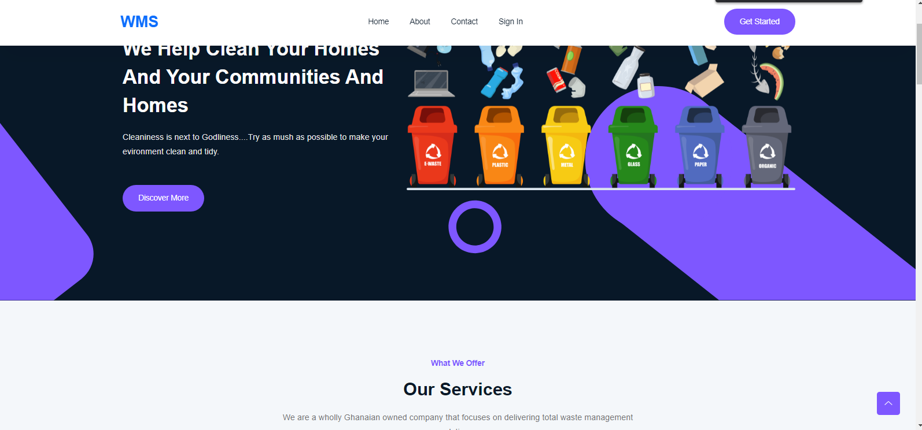

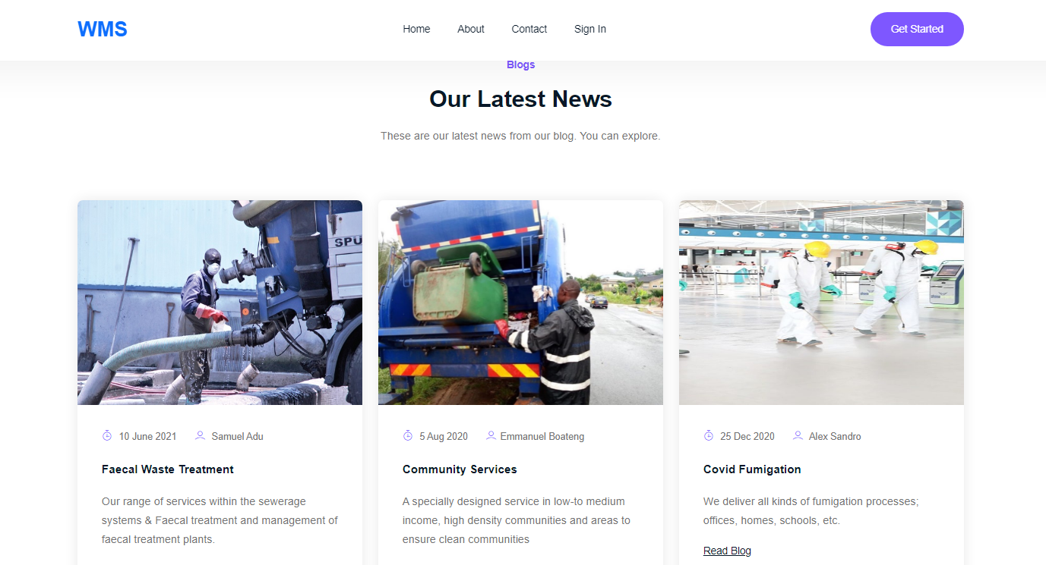

The figure above shows the homepage, which displays the services we offer, testimonial and the links to all other pages (About page, contact page, sign-in page and sign-up page). The page is very interactive which get people’s attention in order to attract more people to sign up to our services.

Fig. 1.2 – **Sign-Up Page**

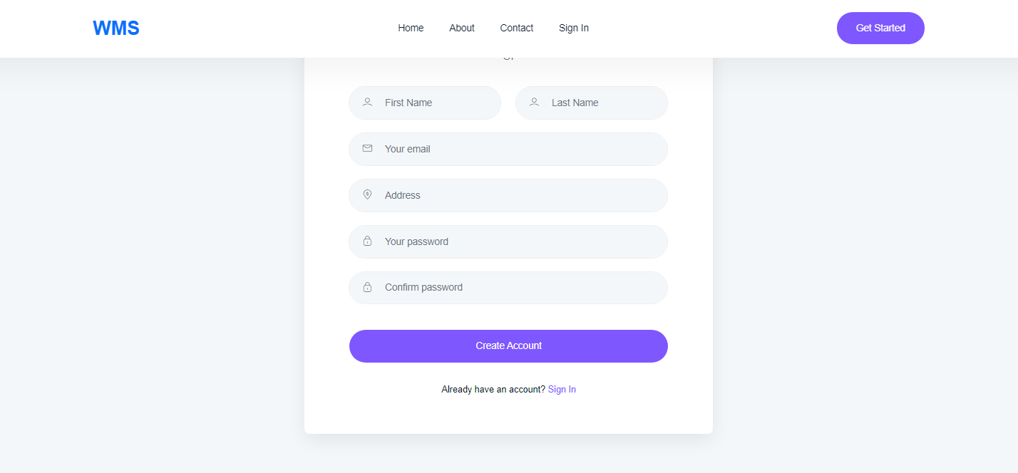

The above figure shows the sign-up page that gets users personal details to be stored into a database. After registration, an activation link is sent to the user’s email for confirmation before the user gets fully registered to become a customer.

Fig. 1.3 – **Login Page.**

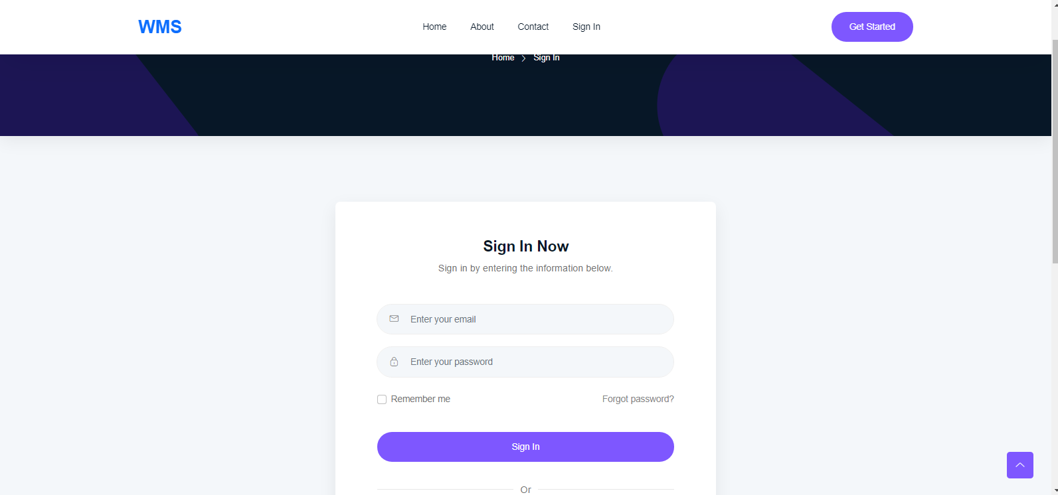

The figure above shows a login page that allows customers to get into their accounts. Customers who have lost or forgotten their password can reset their password after following instructions for password resetting. Correct credentials entered by the customers get them into their various accounts

Fig. 1.5– **Client dashboard**

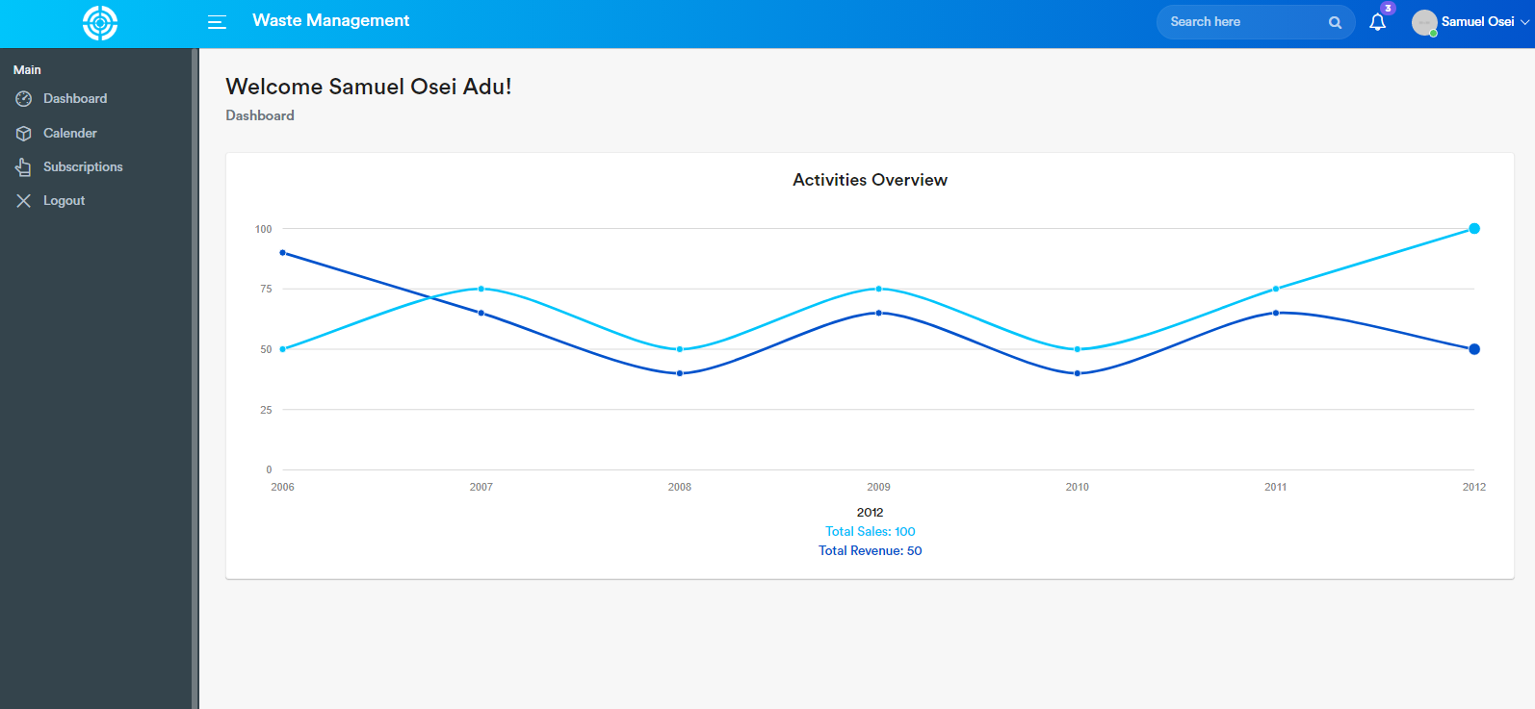

Figure 1.5. shows the dashboard of a client after a successful login. It displays the overview activities of the client. The left panel shows the links to get the client started.

Fig. 1.6 – **Client Calender**

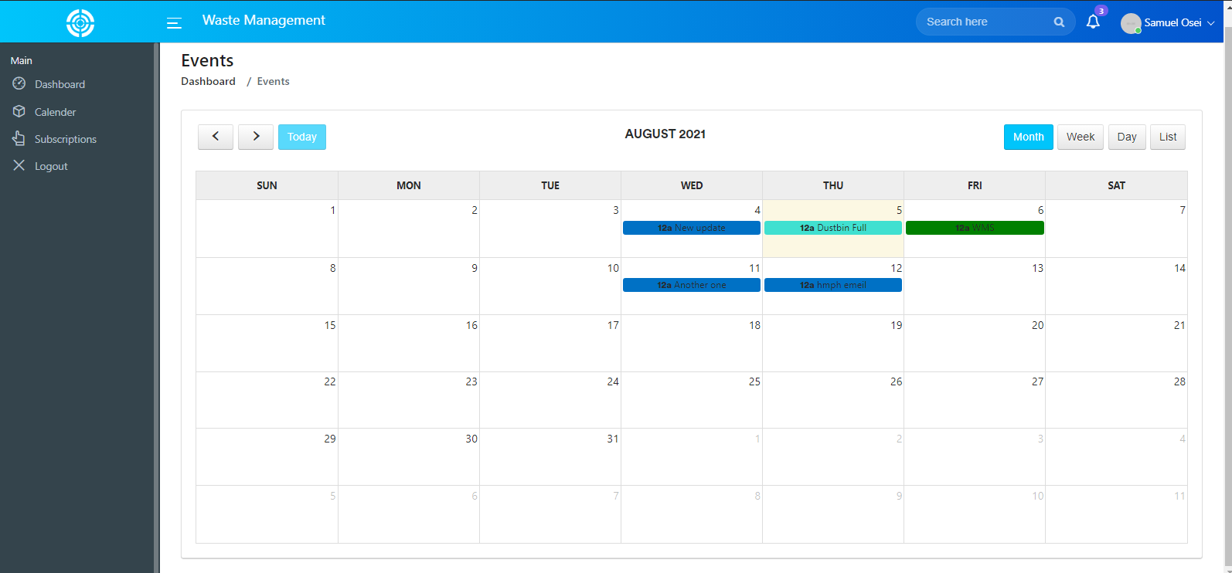

Figure 1.6. shows the events the client has scheduled. Each event can be viewed, edited or deleted by the client and the admin. After successful event addition, a message is sent to the admin for review.

**Fig 1.7. Client Profile Page.**

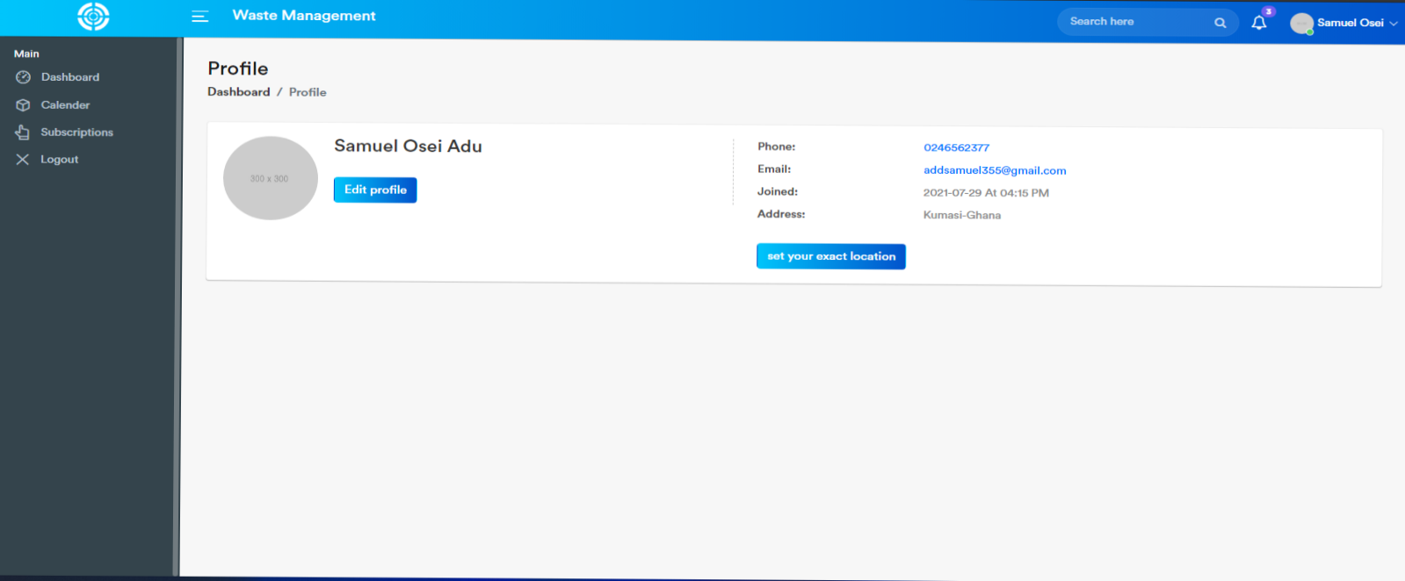

**Fig. 1. 8** The figure above shows the client’s details, client can update his or her details.

### 4.3.1 – Admin Interface Application.

**Admin performs the following duties;**

* + - 1. Update the various pages of the site.
      2. View and update his profile
      3. View, edit, update and delete customers/Clients.
      4. View, edit, update and delete calender events.
      5. Respond to messages send to the server.
      6. Activate and deactivate customers’ accounts.
      7. Sign out.

# CHAPTER 5 - IMPLEMENTATION AND TESTING

## **5.0 - Development Tools And Platforms Consideration**

The User Interface is a web application therefore the platform of the device used to access the site does not matter as long as it possesses a browser capable of accessing the internet, to create the web application the main development tools computer, and software(HTML, CSS, JAVASCRIPT, PHP, MYSQL).

## **5.1 Mapping Logical Design Onto Physical Platforms**

What is required is a practiced and formal approach to gathering data requirements and modelling data. This modelling effort requires a formal approach to the discovery and identification of entities and data elements. Data normalization is a big part of data modelling and database design. A normalized data model reduces data redundancy and inconsistencies by ensuring that the data elements are designed appropriately.

**Logical**

Before the actual database is implemented it was carefully planned out considering the vital pieces of information required by this system.

Data modeling requires a different mindset than requirements gathering for application development and process-oriented tasks. It is important to think “what” is of interest instead of “how” tasks are accomplished.

**Physical**

The first step is to create an initial physical data model by transforming the logical data model into a physical implementation based on an understanding of the Database Management System to be used for deployment. To successfully create a physical database design, you will need to have a good working knowledge of the features.

## **5.2 - Testing**

When it comes to web-based testing, it usually consists of multiple steps that ensures that an application is fully functional and runs smoothly and securely. It is an essential part of the web development and ensures that an app is running properly before its release.

Testing of web-based application includes; functional testing, usability testing, interface testing, compatibility testing, performance testing, and security testing.

**CHAPTER 6 CONCLUSIONS AND RECOMMENDATIONS AND REFERENCES**

## **6.0 - Discussions**

In an ideal community, this technology will be well appreciated, but this is not the case for our country. We are still a developing country therefore some of our citizens might be little skeptical about the idea of using technology to schedule how waste is collected from major areas in the community.

Although this solution is not perfect, there are still quite a number of things that can be done to improve this system for maximum results.

## 6.**1 - Achievements**

With this project we were able to achieve a few things in our implementation of a solution users’ registration, sending messages to a waste collection agent to be delivered to a waste management facility.

## **6.2 – Conclusions**

In conclusion, this system will help solve wastes that have been littered around in our home and communities

## **6.5 - References**

1. Adu-Boahen, K., Atampugre, G., Antwi, K.B., Osman, A., Osei, K.N., Mensah, E.A. and Adu-Boahen, A.O. (2014), “Waste management practices in Ghana: challenges and prospect, Jukwa Central Region”, International Journal of Development and Sustainability, Vol. 3 No. 3, pp. 530-546.
2. Kyere, R., Addaney, M. and Ayaribilla Akudugu, J., 2019. *Decentralization And Solid Waste Management In Urbanizing Ghana: Moving Beyond The Status Quo*. [ebook] Available at: <https://www.intechopen.com/books/municipal-solid-waste-management/decentralization-and-solid-waste-management-in-urbanizing-ghana-moving-beyond-the-status-quo> [Accessed 10 June 2020].
3. Ben Ahmed, M., Boudhir, A. and Younes, A., 2019. *Innovations In Smart Cities Applications Edition 2*. Cham: Springer.
4. 4 Waste Removals. 2020. *There Are 5 Types Of Waste, Do You Know Them All? - 4 Waste Removals*. [online] Available at: <https://4waste.com.au/rubbish-removal/5-types-waste-know/> [Accessed 11 June 2020].
5. Web.mit.edu. n.d. *Decision Makers’ Guide To Municipal Solid Waste Incineration*. [online] Available at: <https://web.mit.edu/urbanupgrading/urbanenvironment/resources/references/pdfs/DecisionMakers.pdf> [Accessed 11 June 2020].
6. Smullins, C., 2011. *An Introduction To Database Design: From Logical To Physical*. [online] Data and Technology Today. Available at: <https://datatechnologytoday.wordpress.com/2011/11/19/an-introduction-to-database-design-from-logical-to-physical/> [Accessed 11 June 2020].